SEC Form 4

FORM 4

Check this box if no longer subject to Section 16. Form 4 or Form 5 obligations may continue. See Instruction 1(b).

Check this box to indicate that a transaction was made pursuant to a contract, instruction or written plan for the purchase or sale of equity securities of the issuer that is intended to satisfy the affirmative defense conditions of Rule 10b5-1(c). See Instruction 10.

UNITED STATES SECURITIES AND EXCHANGE COMMISSION
Washington, D.C. 20549
Washington, D.C. 20549 |  | OMB APPROVAL
STATEMENT OF CHANGES IN BENEFICIAL OWNERSHIP
STATEMENT OF CHANGES IN BENEFICIAL OWNERSHIP |  | OMB Number: | 3235-0287
 |  | Estimated average burden
Filed pursuant to Section 16(a) of the Securities Exchange Act of 1934 |  | hours per response: | 0.5
or Section 30(h) of the Investment Company Act of 1940
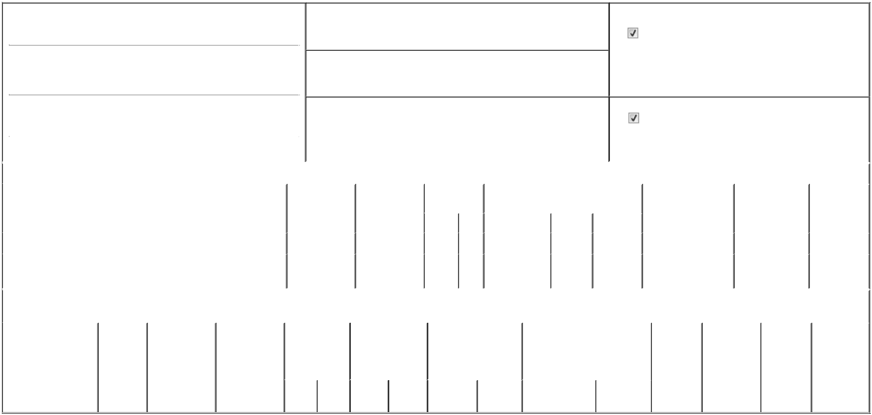

1. Name and Address of Reporting Person*
Bailey John P.

(Last) (First) (Middle)

1441 WEST INNOVATION WAY SUITE 500

2. Issuer Name and Ticker or Trading Symbol

Pattern Group Inc. [ PTRN ]

3. Date of Earliest Transaction (Month/Day/Year)

05/15/2026

- Relationship of Reporting Person(s) to Issuer (Check all applicable)

Director | 10% Owner
Officer (give title | Other (specify below)
below) | Other (specify below)

 | (Street) |  |  |  |  |  | 4. If Amendment, Date of Original Filed (Month/Day/Year) |  |  |  |  |  |  |  | 6. Individual or Joint/Group Filing (Check Applicable Line)
 |  | LEHI | UT | 84043 |  |  |  |  |  |  |  |  |  |  |  |  | Form filed by One Reporting Person
 |  |  |  |  |  |  |  |  |  |  |  |  |  |  |  |  | Form filed by More than One Reporting Person
 |  | (City) | (State) | (Zip)
 |  |  |  |  | Table I - Non-Derivative Securities Acquired, Disposed of, or Beneficially Owned
 | 1. Title of Security (Instr. 3) |  |  |  |  | 2. Transaction |  | 2A. Deemed |  | 3. Transaction |  | 4. Securities Acquired (A) or Disposed Of |  |  |  | 5. Amount of Securities |  |  | 6. Ownership |  | 7. Nature of
 |  |  |  |  |  | Date |  | Execution Date, |  | Code (Instr. 8) (D) (Instr. 3, 4 and 5) |  |  |  |  |  | Beneficially Owned |  |  | Form: Direct (D) or |  | Indirect
 |  |  |  |  |  | (Month/Day/Year) |  | if any |  |  |  |  |  |  |  | Following Reported |  |  | Indirect (I) (Instr. 4) |  | Beneficial
 |  |  |  |  |  |  |  | (Month/Day/Year) |  | Code | V | Amount |  | (A) or (D) | Price | Transaction(s) (Instr. 3 |  |  |  |  | Ownership
 |  |  |  |  |  |  |  |  |  | Code | V | Amount |  | (A) or (D) | Price | and 4) |  |  |  |  | (Instr. 4)
 | Series A Common Stock |  |  |  |  | 05/15/2026 |  |  |  | A |  | 11,356⁽¹⁾ |  | A | $0 | 11,356 |  |  |  | D
 | Series A Common Stock |  |  |  |  |  |  |  |  |  |  |  |  |  |  | 28,176,542 |  |  |  | I | See
 |  |  |  |  |  |  |  |  |  |  |  |  |  |  |  |  |  |  |  | I | footnote⁽²⁾
 |  |  |  |  | Table II - Derivative Securities Acquired, Disposed of, or Beneficially Owned
 |  |  |  |  |  | (e.g., puts, calls, warrants, options, convertible securities)
 | 1. Title of Derivative |  | 2. | 3. Transaction | 3A. Deemed | 4. Transaction |  | 5. Number of |  | 6. Date Exercisable and |  |  | 7. Title and Amount of Securities |  |  |  | 8. Price of | 9. Number of |  | 10. | 11. Nature of
 | Security (Instr. 3) |  | Conversion | Date | Execution Date, | Code (Instr. 8) |  | Derivative |  | Expiration Date |  |  | Underlying Derivative Security |  |  |  | Derivative | derivative |  | Ownership | Indirect
 |  |  | or Exercise | (Month/Day/Year) | if any |  |  | Securities Acquired |  | (Month/Day/Year) |  |  | (Instr. 3 and 4) |  |  |  | Security | Securities |  | Form: | Beneficial
 |  |  | Price of |  | (Month/Day/Year) |  |  | (A) or Disposed of |  |  |  |  |  |  |  |  | (Instr. 5) | Beneficially |  | Direct (D) or | Ownership
 |  |  | Derivative |  |  |  |  | (D) (Instr. 3, 4 and |  |  |  |  |  |  |  |  |  | Owned |  | Indirect (I) | (Instr. 4)
 |  |  | Security |  |  |  |  | 5) |  |  |  |  |  |  |  |  |  | Following |  | (Instr. 4)
 |  |  |  |  |  |  |  |  |  |  |  |  |  |  |  |  |  | Reported
 |  |  |  |  |  |  |  |  |  |  |  |  |  |  | Amount or |  |  | Transaction(s)
 |  |  |  |  |  |  |  |  |  | Date |  | Expiration |  |  | Number of |  |  | (Instr. 4)
 |  |  |  |  |  | Code V |  | (A) | (D) | Exercisable |  | Date | Title |  | Shares

Explanation of Responses:

- These shares represent restricted stock units (RSUs) granted on May 15, 2026, which fully vest on the earlier of (i) May 15, 2027, or (ii) the date of the issuer's 2027 Annual Meeting of Stockholders, subject to the continued service of the reporting person to the issuer through the applicable vesting date. Each RSU represents a contingent right to receive one share of Series A common stock.

- The reported securities are held directly by KL Pattern Holdings LP (the "KL Shareholder") and KLC Fund I LP ("KLC Fund I"). The management of the KL Shareholder and the management of KLC Fund I are controlled by KLC Fund I GP LP ("KLC Fund GP"). KLC Fund I UGP LLC ("KLC Fund UGP") is the general partner of KLC Fund GP. The management of KLC Fund UGP is controlled by its managing member, John Bailey. As such, Mr. Bailey may be deemed to have voting and dispositive power with respect to the shares held by the KL Shareholder and KLC Fund I but disclaims beneficial ownership except to the extent of his pecuniary interest therein.

Remarks:

 | /s/ Allison Fletcher, Attorney-in-Fact |  |  | 05/19/2026
 | ** Signature of Reporting Person |  | Date
Reminder: Report on a separate line for each class of securities beneficially owned directly or indirectly.
* If the form is filed by more than one reporting person, see Instruction 4 (b)(v).
** Intentional misstatements or omissions of facts constitute Federal Criminal Violations See 18 U.S.C. 1001 and 15 U.S.C. 78ff(a).
Note: File three copies of this Form, one of which must be manually signed. If space is insufficient, see Instruction 6 for procedure.
Persons who respond to the collection of information contained in this form are not required to respond unless the form displays a currently valid OMB Number.



